

ACCOMMODATION PRICES AT HOSTEL TITIUS

Price per room at Hostel Titius
January - April / October - December
Room type Anchor price 10.9.2026 Category I Anchor price 10.9.2026 Category II
1/1 | Single room for the disabled 20,00 € | 20,00 € | 18,00 € | 18,00 €
1/1 | Single room 36,00 € | 36,00 € | 32,40 € | 32,40 €
2/1 | Double room 40,00 € | 40,00 € | 36,00 € | 36,00 €
3/1 | Triple room 57,00 € | 57,00 € | 51,30 € | 51,30 €
4/1 | Quadruple room 64,00 € | 64,00 € | 64,00 € | 57,60 €
 | Apartment *** 66,00 € | 66,00 € | 66,00 € | 60,00 €
 | Extra bed 13,00 € | 13,00 € | 13,00 € | 13,00 €

May - September
Room type Anchor price 10.9.2026 Category I Anchor price 10.9.2026 Category II
1/1 | Single room for the disabled 20,00 € | 20,00 € | 18,00 € | 18,00 €
1/1 | Single room 40,00 € | 40,00 € | 36,00 € | 36,00 €
2/1 | Double room 60,00 € | 60,00 € | 54,00 € | 54,00 €
3/1 | Triple room 69,00 € | 69,00 € | 62,10 € | 62,10 €
4/1 | Quadruple room 80,00 € | 80,00 € | 72,00 € | 72,00 €
 | Apartment *** 80,00 € | 80,00 € | 72,00 € | 72,00 €
 | Extra bed 13,00 € | 13,00 € | 13,00 € | 13,00 €
Price includes VAT.
The Public Institute of Krka National Park reserves the right to change prices.
Price does not include tourist tax.

Requests and reservations: hostel.titius@npk.hr
Contact us: +385912254205; 385912254370
Where to find us: LOCATION
Category I – price for accommodation clients
Category II – price for accommodation clients: students, children from 4 to 18 years, members of the Friends of the Krka Club, organisations conducting volunteer programmes, institutions involved in environmental protection, members of Croatian Hiking Society, persons with a European Disability Card and one accompanying person, individuals with special needs, and individuals with over 50% disability (as well as one accompanying person) upon presentation of an identification card.
Krka NP volunteers have free accommodation in the Hostel. Children up to 4 years of age have free accommodation in the Hostel and apartment. Hostel and apartment users are entitled to a free entrance ticket for the upper course of the Park (Krka Eco Campus, Burnum, Manojlovac, Krka – well of life and Roški slap waterfall) for the duration of their stay at the Hostel.
The Tourist Tax Act (OG 40/21) governs the obligations and means of payment of the fee per person per day for adults. The total amount of tourist tax is charged at the same time as the total price for accommodations.

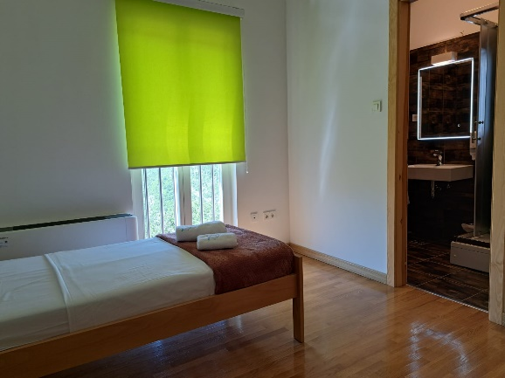
At the time of sending the reservation for a specific time slot or payment of the reservation online, the client is bound by the General Terms of Operations and Use. The General Terms are available in electronic form on the website and are available to every client at any time

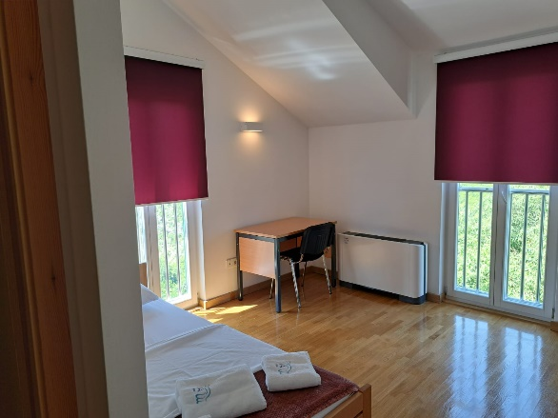

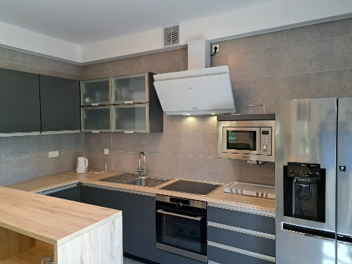

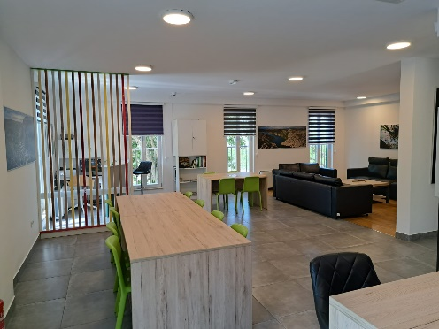

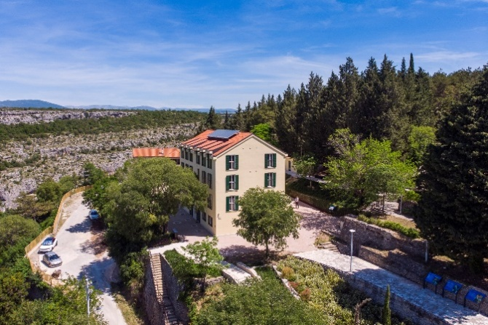

Requests and reservations: hostel.titius@npk.hr
Contact us: +385912254205; 385912254370
Where to find us: LOCATION
Price per bed (person) at the Hostel Titius

January - April / October - December
Room type Anchor price 10.9.2026 Category I Anchor price 10.9.2026 Category II
1/1 | Single room for the disabled 20,00 € | 20,00 € |  | 18,00 € 18,00 €
1/1 | Single room 36,00 € | 36,00 € |  | 32,40 € 32,40 €
2/1 | Double room 20,00 € | 20,00 € |  | 18,00 € 18,00 €
3/1 | Triple room 19,00 € | 19,00 € |  | 17,10 € 17,10 €
4/1 | Quadruple room 16,00 € | 16,00 € |  | 14,40 € 14,40 €
 | Extra bed 13,00 € | 13,00 € |  | 13,00 € 13,00 €

May - September
Room type Anchor price 10.9.2026 Category I Anchor price 10.9.2026 Category II
1/1 | Single room for the disabled 20,00 € | 20,00 € |  | 18,00 € 18,00 €
1/1 | Single room 40,00 € | 40,00 € |  | 36,00 € 36,00 €
2/1 | Double room 30,00 € | 30,00 € |  | 27,00 € 27,00 €
3/1 | Triple room 23,00 € | 23,00 € |  | 20,70 € 20,70 €
4/1 | Quadruple room 20,00 € | 20,00 € |  | 18,00 € 18,00 €
 | Extra bed 13,00 € | 13,00 € |  | 13,00 € 13,00 €

Price does not include tourist tax Price includes VAT.
The Public Institute of Krka National Park reserves the right to change prices.
Price does not include tourist tax Price per bed (person) at the Hostel Titius

At the time of sending the reservation for a specific time slot or payment of the reservation online, the client is bound by the General Terms of Operations and Use. The General Terms are available in electronic form on the website and are available to every client at any time.

SELF-SERVICE LAUNDROMAT PRICES AT THE KRKA ECO CAMPUS, PULJANE, HOSTEL TITIUS

Anchor price 10.9.2026
Tokens for the self-service laundromat – 1 token 2,00 € | 2,00 €
Washing/service 4,00 € | 4,00 €
Drying/service 2,00 € | 2,00 €
Price includes VAT.
The Public Institute of Krka National Park reserves the right to change prices.

BICYCLE RENTAL PRICES

Anchor price 10.9.2026
Rental service 1 h 15,00 € | 15,00 €
Rental service to 3 h 30,00 € | 30,00 €
Rental service over 4 h 40,00 € | 40,00 €
Price includes VAT.
The Public Institute of Krka National Park reserves the right to change prices.

Contact us: +385912254231; +385912254205
Where to find us: LOCATION
More information Krka Bike

